MY S

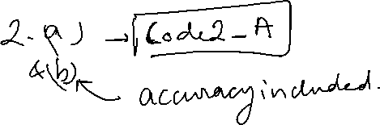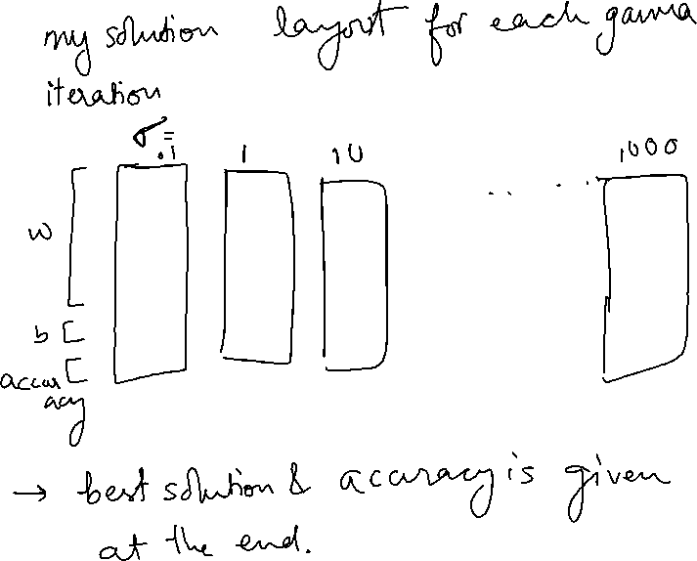

gamma =



1.00000000000000e+000

solution_list =

379.461189981329e+000

211.601624531205e+000

2.64841892385076e+003

36.7959622070941e+003

706.988101106296e-003

4.70962918695629e+000

7.65977026365298e+000

4.25508367390448e+000

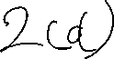

1.36914594378743e+000

-11.1535172448187e-003

-23.8476077171996e+006



925.675675675676e-003

bestgamma =

1.00000000000000e+000

bestsigma =

100.000000000000e-003

>>